  
  
  
**Department of Computer Engineering & Applications**

**Institute of Engineering & Technology**

**GLA University**

**Mathura- 281406, INDIA**

**03, May, 2025  
  
DexVPN**

# *A Project Report submitted in partial fulfillment of the requirements for the award of the degree of* Bachelor of Computer Applications By

|  |  |
| --- | --- |
| **Mr. Lalit Kumar Badhotiya** | **(2342010350)** |
| **Mr. Gaurav Singh Sisodia** | **(2342010218)** |
| **Mr. Karan Singh Sikarwar** | **(2342010305)** |
| **Mr. Lokendra Dixit** | **(2342010354)** |
| **Mr. Luv Kumar Dixit** | **(2342010354)** |
| **Mr. Kunjan Chaudhary** | **(2342010354)** |
|  |  |

Under the Guidance of

**Dr. Anuj Mangal**

**(Assistant Professor)**

## 

**Department of Computer Engineering  
 Applications GLA University, Mathura**

**17 km. Stone NH19, Mathura-Delhi Road,**

**P.O. – Chaumuhan, Mathura – 281406U.P (India**

**Declaration**

We hereby declare that the work which is being presented in the B.C.A. Project **“DexVPN”**, in complete fulfillment of the requirements for the award of the ***Bachelor of Computer Applications*** and submitted to the Department of Computer Engineering and Applications of GLA University, Mathura, is an authentic record of our own work carried under the supervision of **Dr. Anuj Mangal .**

The contents of this project report, in full or in parts, have not been submitted to any other institute or university for the award of any degree.

|  |  |
| --- | --- |
| **Mr. Lalit Kumar Badhotiya** | **(2342010350)** |
| **Mr. Gaurav Singh Sisodia** | **(2342010218)** |
| **Mr. Karan Singh Sikarwar** | **(2342010305)** |
| **Mr. Lokendra Dixit** | **(2342010354)** |
| **Mr. Luv Kumar Dixit** | **(2342010354)** |
| **Mr. Kunjan Chaudhary** | **(2342010354)** |
|  |  |

**Abstract**

The project "DEX VPN" is a cross-platform Virtual Private Network (VPN) application developed using Flutter, aimed at providing users with secure, private, and unrestricted internet access. DEX VPN offers a clean and minimalistic interface tailored for students and professionals seeking a lightweight and efficient VPN solution. The application enables users to connect to global VPN servers by dynamically fetching available server locations through a free and public API—completely eliminating the need for backend hosting or server maintenance. With features like real- time location updates, secure connection toggling, and a smooth user experience, DEX VPN ensures online privacy and data protection. This project highlights the importance of digital freedom and security, allowing users to bypass geographic restrictions and safeguard their online activity with ease.

**CONTENTS**

|  |  |
| --- | --- |
| **Topic**  Certificate Acknowledgement | **Pg.no.**  1  2 |
| Chapter1 Introduction | 3 |
| 1.1 Overview &Motivation | 4 |
| 1.2 Organization of Project Report | 4 |
| Chapter2 Software Requirement Analysis | 5 |
| 2.1 Requirement Analysis | 5 |
| 2.1.1 Hardware Requirement | 5 |
| 2.1.2 Software Requirement | 6 |
| 2.1.3 Tools and Technologies | 6 |
| 2.2 Feasibility Study | 7 |
| 2.2.1 Technical Feasibility | 6 |
| 2.2.3 Economical Feasibility | 8 |
| 2.3 Analysis | 8 |
| 2.4 Summary of Modules | 9 |
| Chapter3 Software Design | 10 |
| 3.1 DFD | 10 |
| DFD Level 0 | 12 |
| DFD Level 1 | 13 |
| Chapter 4 Implementation & User Interface | 17 |

|  |  |
| --- | --- |
| Chapter 5 Software Testing | 14 |
| 5.1 Testing | 14 |
| 5.2 Objectives of Software Testing | 14 |
| 5.3 Principles of Software Testing | 15 |
| 5.3.1 White Box Testing | 15 |
| 5.3.2 Black Box Testing | 15 |
| 5.4 Testing Fundamentals | 16 |
| 5.5 Testing Information | 16 |
| Conclusion | 23 |
| References | 24 |
|  |  |

Certificate

This is to certify that the above statements made by the candidates are correct to the best of my/our knowledge and belief.

#### Project Supervisor Date:

**(Mr. Anuj Mangal)**

Project In charge Program Coordinator Head of Department

**(Mr. D.P Yadav) (Mr. Narendra Mohan) (Dr. Rohit Agrawal)**

**ACKNOWLEDGEMENT**

The satisfaction which accompanies the successful completion of the project, is incomplete without the mention of a few names. We take this opportunity to acknowledge the efforts of the many individuals who helped us to make this project possible. Firstly, we would like to express our heartfelt appreciation and gratitude to our project guide **Mr. Anuj Mangal, (Assistant Professor), Computer Engineering Department.** His vision and execution aimed at creating a structure, definition and realism around the project and fostered the ideal environment for us to learn and do. This project is a result of he’s teaching, encouragement and inputs in the numerous meetings he had with us, despite his busy schedule. We would also like to extend our immense gratitude to respected Head of Department **Dr. Rohit Agrawal** who allowed us to choose the topic for our dissertation.

The experience was novel one and we would like to thank all the people, who have lent their valuable time for the completion of the report. Without their consideration it would have been difficult to complete the report.

Chapter 1**Introduction**

## The project "DexVPN" aims to provide users with a convenient and reliable solution for secure internet access and online privacy. This project seeks to bridge the gap between the growing concern for digital safety and the availability of free, accessible VPN services. By utilizing modern technology and a cross-platform mobile app built in Flutter, DexVPN simplifies the process of connecting to secure servers around the world.

## We understand that protecting personal data and accessing unrestricted content can often be difficult without technical expertise or paid subscriptions. Therefore, this project offers a user-friendly and minimalistic platform where users can easily select a location, connect to a VPN server, and browse the internet with enhanced privacy and freedom. DexVPN makes use of publicly available APIs to fetch live server locations, removing the need for backend hosting while keeping the experience fast and lightweight.

## Our goal is to deliver a secure and smooth VPN experience that ensures privacy and satisfaction for all users. We believe that DexVPN will bring ease and confidence to users seeking online freedom, especially those who lead busy lives or operate on a budget. We are committed to providing an efficient, free, and trustworthy service that puts your internet safety first.

## Present Problem Statement:

In today’s digital age, users often struggle to protect their online privacy and access restricted content. Most VPN services are either paid, complex, or require backend setup, making them less accessible to everyday users .

Key features include:

• Easy-to-use interface

• Real-time VPN server location listing

• One-tap connection toggle

## Proposed System:

• This VPN service provides users with secure and private internet access, ensuring online safety and freedom.

• With the help of this mobile application, users can easily connect to global VPN servers without requiring any backend setup.

• All users need to do is open the app, select a location, and tap to connect for secure browsing.

• Provides a simple and user-friendly platform to protect data and bypass restrictions.

• There are two modules in this project:  
 • **User** – Can connect/disconnect VPN, select server location, and browse securely.  
 • **System (App Logic)** – Handles server listing, connection management, and secure routing.

* 1. **Overview and Motivation:**

## Overview:

## DEX VPN is a mobile application designed to provide users—especially students and professionals—with secure and private internet access. It offers an effective and efficient way to connect to global VPN servers, ensuring online privacy, anonymity, and access to restricted content without the need for backend setup. DEX VPN is a lightweight, Flutter-based solution aimed at delivering free, fast, and secure browsing for users.

## Motivation:

1. Provides a secure online experience.
2. User Friendly.

## Organization of Project Report:

|  |  |
| --- | --- |
| **PHASES** | **TIME DURATION** |
| Software requirement specification | 1 weeks |
| System design | 1 weeks |
| Coding | 9 weeks |
| Testing | 1 weeks |
| Documentation | 1 weeks |
| Implementation | 1 weeks |

Chapter 2**Software Requirement Analysis**

Software Requirement Analysis is the process of identifying the functional and non-functional requirements of a software system.

Here are some of the key requirements that should be considered when designing a VPN application like DEX VPN:

• User Authentication and Management  
• Server Location Management  
• Secure Data Transmission  
• Connection Status and Logs  
• Privacy and Security Protocols

## Requirement Analysis

Information gathering is the first phase of the software development project. The purpose of this phase is to identify and document the exact needs for the VPN system. The user’s demand highlights the need for secure, reliable, and easy-to-use internet privacy solutions. During investigation, the core requirement was redefined to focus on providing an efficient mobile VPN app that uses publicly available VPN servers to ensure user privacy and freedom.

The major steps are –  
• Defining the user requirements for connection, location selection, and data security.  
• Studying existing VPN apps to identify gaps and challenges.  
• Defining the expected performance and ease of use for users operating the application.

#### **Hardware Requirements**

Processor : Qualcomm Snapdragon

RAM : 1 GB

Storage : 200 MB of free space

#### **Software Requirements**

**Operating System** : Windows7 and higher

**Front End** : Flutter, Dart

**Back End** : Dart, Vpngate APIs

#### **Tools and Technology:**

* + - * Flutter SDKVS Code
      * Dart Programming Language
      * ExcelDraw
      * Android Studio

#### **Technology:**

• **Flutter**: Flutter is a UI toolkit for building natively compiled applications for mobile, web, and desktop from a single codebase. It enables high-performance apps with smooth user interfaces.

• **Dart**: Dart is the programming language used with Flutter for building mobile, desktop, and web applications. It is object-oriented and designed for client-side development, providing an efficient and easy-to-learn syntax.

• **VPN APIs**: VPN APIs are used to provide real-time data on available VPN server locations. These APIs allow the DexVPN app to fetch server information dynamically, ensuring users can connect to servers in different regions.

• **Android Studio**: These are integrated development environments (IDEs) for building, testing, and deploying applications on Android and iOS platforms. Android Studio is used for Android development.

• **Visual Studio Code**: A lightweight code editor that is widely used for Flutter development. It supports extensions for Flutter and Dart and provides tools for debugging and version control.

## Feasibility Study

A feasibility study is the process of determining whether or not a project is worth pursuing. Feasibility studies are conducted within specific time constraints and typically result in both written and oral reports. In this project, we performed a feasibility study with developers within a fixed timeframe. The findings and recommendations from this study helped guide the decision-making process, such as choosing appropriate software and hardware combinations.

#### **Technical feasibility:**

Technical feasibility is concerned with identifying the required software and hardware to meet user requirements. The technical needs of the system may vary, but generally include:

•The ability to produce output in a given time.  
• Response time under specific conditions.  
• Compatibility between the front-end and back-end systems.

For **DexVPN**, the system's technical feasibility is strong. Flutter, the front-end framework, and Dart, the programming language, are highly compatible with the mobile platforms (Android and iOS). The integration of APIs for fetching server locations is seamless, and the system responds quickly when users interact with the app, offering smooth VPN connections without delay.

The compatibility of **Flutter** with **Firebase** (potential future integration) ensures secure user authentication and data storage. The response time when selecting VPN servers and connecting to them is very fast, providing users with near-instant access to secure browsing.

The system's configuration is optimized to ensure smooth performance, with minimal risk of failure under regular usage. The app's design is based on **Flutter** and **Dart**, which have proven to be highly effective for mobile application development. The VPN connection speed remains stable, and the process of switching between servers is quick and responsive.

The front-end design uses **Flutter** and **Dart**, providing a user-friendly interface. These technologies ensure easy implementation, clear user flow, and stable integration with the backend services. The system is designed to handle a wide range of devices, and any future hardware upgrades will not disrupt the system’s performance. Moreover, should any module encounter issues, it will not affect the overall system’s functionality.

#### **Economic Feasibility:**

Economic analysis is one of the most frequently used techniques for evaluating the effectiveness of a proposed system. This is commonly referred to as **cost/benefit analysis**. The goal is to determine the expected benefits and savings of the proposed system and compare them to the costs. If the benefits outweigh the costs, the decision is made to proceed with the design and implementation of the system. If the costs exceed the benefits, alternative solutions or further justification for the proposed system must be provided.

For **DexVPN**, the primary costs involved include development time, technology stack (such as Flutter and Firebase), and any ongoing operational costs related to using VPN servers and APIs. However, since **DexVPN** does not require heavy server infrastructure and instead leverages existing public VPN APIs, the operational costs are relatively low.

**Benefits:** • Improved online security and privacy for users.  
• No backend infrastructure or server hosting costs.  
• Easy scalability through integration with third-party APIs.  
• Lower development cost by using open-source technologies like Flutter and Dart.

The **economic feasibility** of the project is very favourable, as the primary investment is in the development phase. The ongoing maintenance and operational costs are minimal, as the VPN servers are provided by external services, and the app requires no expensive infrastructure. This makes **DexVPN** a cost-effective solution for users while providing the required functionality at a competitive price.

## Analysis

System analysis is the first step in the software development process. The purpose of system analysis is to thoroughly understand the system requirements, identify the data, functional, and behavioural requirements, and build models that help in understanding the system better.

In the process of system analysis, we first examine the existing system (if applicable) and understand its workings (i.e., its processes). Once we have a clear understanding of the current system, we can identify problems or areas for improvement. By evaluating the current issues and desired outcomes (both input and output), the analyst explores possible solutions.

For **DEX VPN**, the system analysis process involves defining the core components of the app:  
• **Data Objects**: These include the VPN server locations, user authentication data, and VPN connection settings.  
• **Processing Functions**: These refer to how the app processes requests such as connecting to a VPN server, displaying available server locations, and switching between servers.  
• **Behaviour**: This defines how the app interacts with users, handles VPN connections, and maintains data privacy and security during use.

By analysing these aspects, we create models that help in understanding the flow of data, system functions, and user interactions. These models enable us to design an optimized system architecture, ensuring smooth operation and secure connections for users.

The models developed during system analysis will ensure that the VPN app is built to meet user expectations, provide seamless functionality, and address any potential issues related to data flow, connection speed, or security.

## Summary of Modules

1. Administrator
2. Client (user)

#### **Administrator**

The **Administrator** module is responsible for overseeing the overall operations of the VPN platform. The administrator manages the backend of the app, which includes overseeing user accounts, monitoring VPN server status, and ensuring the availability of servers for users. The administrator also has control over the connection logs, user activity, and the smooth functioning of the app. Any changes or updates to the VPN server list, maintenance schedules, or API configurations will be handled through this module.

#### **Client**

The **User (Client)** module focuses on the user experience. Users can register or log in with their credentials and securely access the app. They can browse through the available VPN servers, select their desired server location, and establish a secure connection. The client module is designed to authenticate the user, ensure proper access to VPN features, and allow users to easily toggle the VPN connection. Additionally, users can manage their profiles and settings through this module.

Chapter 3**Software Design**

A Software Design Document (SDD) is a comprehensive written description of a software product that provides the development team with overall guidance regarding the architecture of the project. The SDD serves as a blueprint, detailing how the software components will work together. It accompanies architecture diagrams, feature specifications, and outlines the design for the development process. The purpose of this document is to provide clear, high-level guidance and ensure all team members are aligned under a unified vision for the project.

The Software Design Document for **DexVPN** will be structured in two parts: **High-Level Design Document (HLDD)** and **Low-Level Design Document (LLDD)**. These documents provide different levels of detail about the system's architecture and functionality.

The SDD for **DexVPN** contains the following components:

**1. Data Design:**  
This section describes the data structures within the **DexVPN** application. Key data objects include the user’s account details, VPN server information (location, status, and connection details), and session logs. The relationships between these objects are defined, ensuring the proper flow and storage of information. The system uses lightweight local storage for user preferences and connects to external APIs for server data retrieval.

**2. Design Flow & Data Mapping:**  
In this design section, the data flow within the **DexVPN** application is mapped out. The system will retrieve server data from external sources via API, allow users to select VPN locations, and provide a secure connection. The flow of information will be carefully separated into modules for clear processing, ensuring smooth interactions between input (user requests), processing (VPN connection setup), and output (successful connection and user feedback).

**3. Interface Design:**  
The **DexVPN** app requires both internal and external interfaces. Internal interfaces involve how the app connects to external APIs to retrieve available VPN server locations. External interfaces will focus on how the app interacts with users via the graphical user interface (GUI). The design will ensure ease of use, with simple login screens, server selection, and toggle connection functionality. All interfaces are designed for smooth user interactions, ensuring a user-friendly experience.

## Data Flow Diagram (DFD)

The Data Flow Diagram (DFD) is a graphical representation of the flow of data through an information system. It enables you to represent the processes in your information system from the viewpoint of data. The DFD lets you visualize how the system operates, what the system accomplishes and how it will be implemented, when it is refined with further specification.

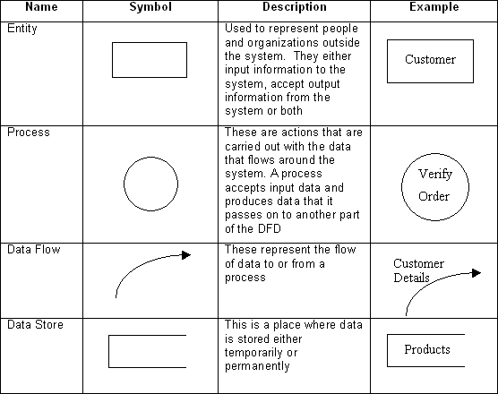Data flow diagrams are used by systems analysts to design information-processing systems but also as a way to model whole organizations. You build a DFD at the very beginning of your business process modeling in order to model the functions your system has to carry out and the interaction between those functions together with focusing on data exchanges between processes. You can associate data with conceptual, logical, and physical data models and object-oriented models.

**Fig 3.1 Data Flow Diagram Symbol**

**Data Flow Diagram level - 0**

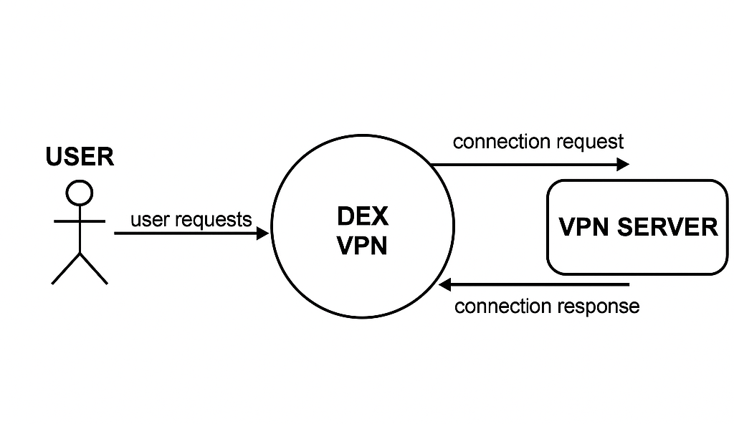

**Data Flow Diagram Level 1**

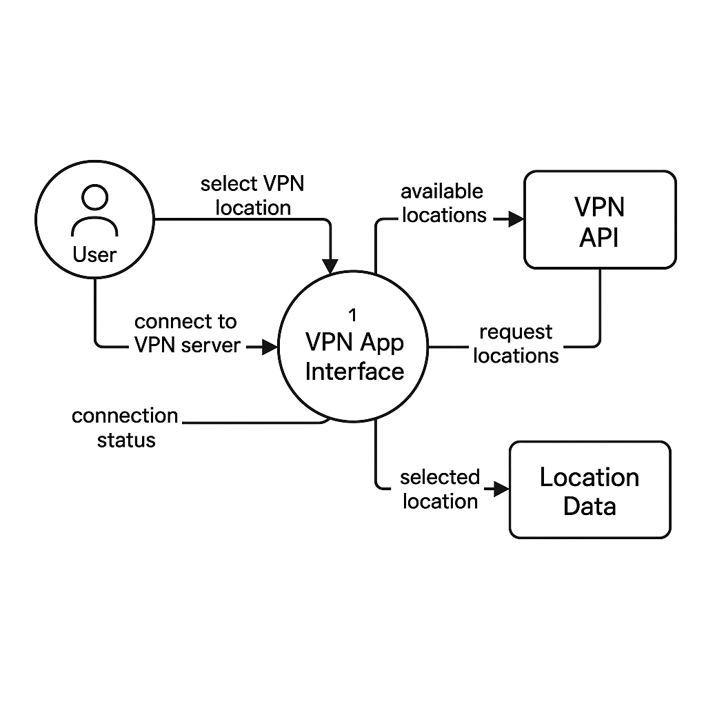

**Chapter 4 SOFTWARE TESTING**



## 4.1 Testing

* + - Software testing is the process of executing a program with intension of finding errors in the code. It is a process of evolution of system or its parts by manual or automatic means to verify that it is satisfying specified or requirements or not.
    - Generally, no system is perfect due to communication problems between user and developer, time constraints, or conceptual mistakes by developer.
    - To purpose of system testing is to check and find out these errors or faults as early as possible so losses due to it can be saved.
    - Testing is the fundamental process of software success.
    - Testing is not a distinct phase in system development life cycle but should be applicable throughout all phases i.e. design development and maintenance phase.
    - Testing is used to show incorrectness and considered to success when an error is detected.

## Objectives of Software Testing

* + - **Software Quality Improvement:** The computer and the software are mainly used for complex and critical applications and a bug or fault in software causes severe losses. So a great consideration is required for checking for quality of software.

#### **Verification and Validation:**

* + Verification means to test that we are building the product in right way. i.e. are we using the correct procedure for the development of software so that it can meet the user requirements.
  + Validation means to check whether we are building the right product or not.
    - **Software Reliability Estimation:** The objective is to discover the residual designing errors before delivery to the customer. The failure data during process are taken down in order to estimate the software reliability.

## Principles of Software Testing

* + 1. All tests should be traceable to end user requirements.
    2. Tests should be planned long before testing begins.
    3. Testing should begin on a small scale and progress towards testing in large.
    4. To be most effective testing should be conducted by an independent third party.

The primary objective for test case design is to derive a set of tests that has the highest livelihood for uncovering defects in software. To accomplish this objective two different categories of test case design techniques are used. They are

* + 1. White box testing.
    2. Black box testing.

#### **White-box testing:**

White box testing focus on the program control structure. Test cases are derived to ensure that all statements in the program have been executed at least once during testing and that all logical conditions have been executed.

* **Block-box testing:**

Black box testing is designed to validate functional requirements without regard to the internal workings of a program. Black box testing mainly focuses on the information domain of the software, deriving test cases by partitioning input and output in a manner that provides through test coverage. Incorrect and missing functions, interface errors, errors in data structures, error in functional logic are the errors falling in this category.

## Testing fundamentals

Testing is a process of executing program with the intent of finding error. A good test case is one that has high probability of finding an undiscovered error. If testing is conducted successfully it uncovers the errors in the software. Testing cannot show the absence of defects, it can only show that software defects present.

## Testing Information flow

Information flow for testing flows the pattern. Two class of input provided to test the process. The software configuration includes a software requirements specification, a design specification and source code.

Test configuration includes test plan and test cases and test tools. Tests are conducted and all there are evaluated. That is test results are compared with expected results. When erroneous data are uncovered, an error is implied and debugging commences.

Chapter 5 **Implementation and User Interface**

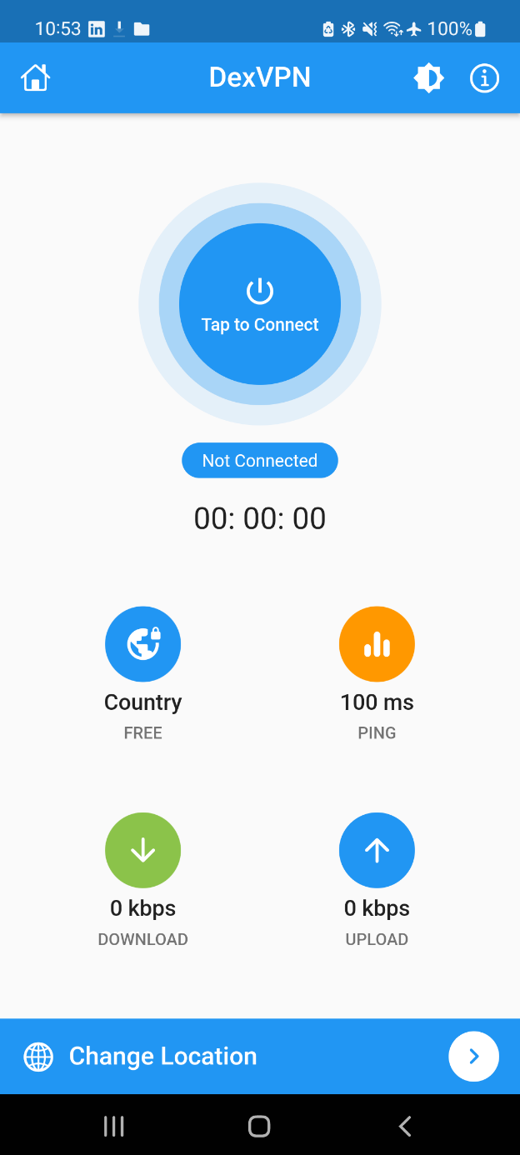 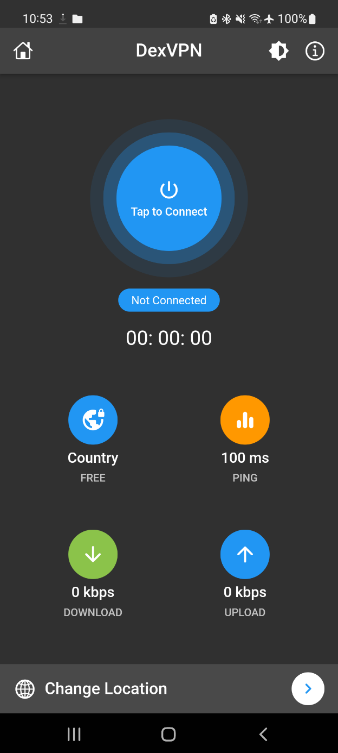

Fig no. 1,2

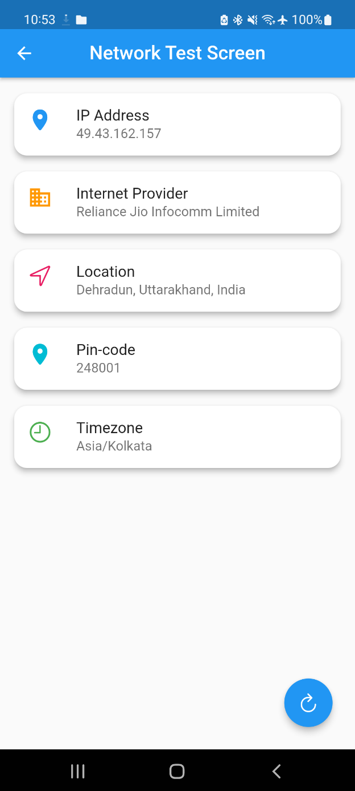 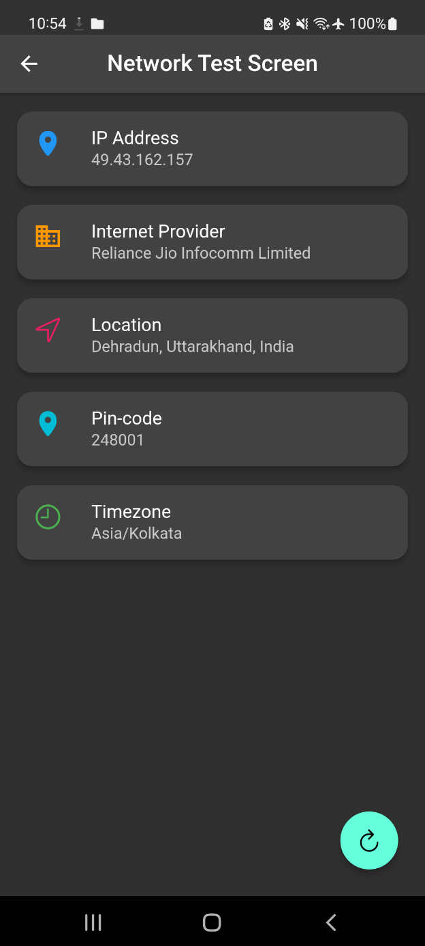

Fig no. 3,4

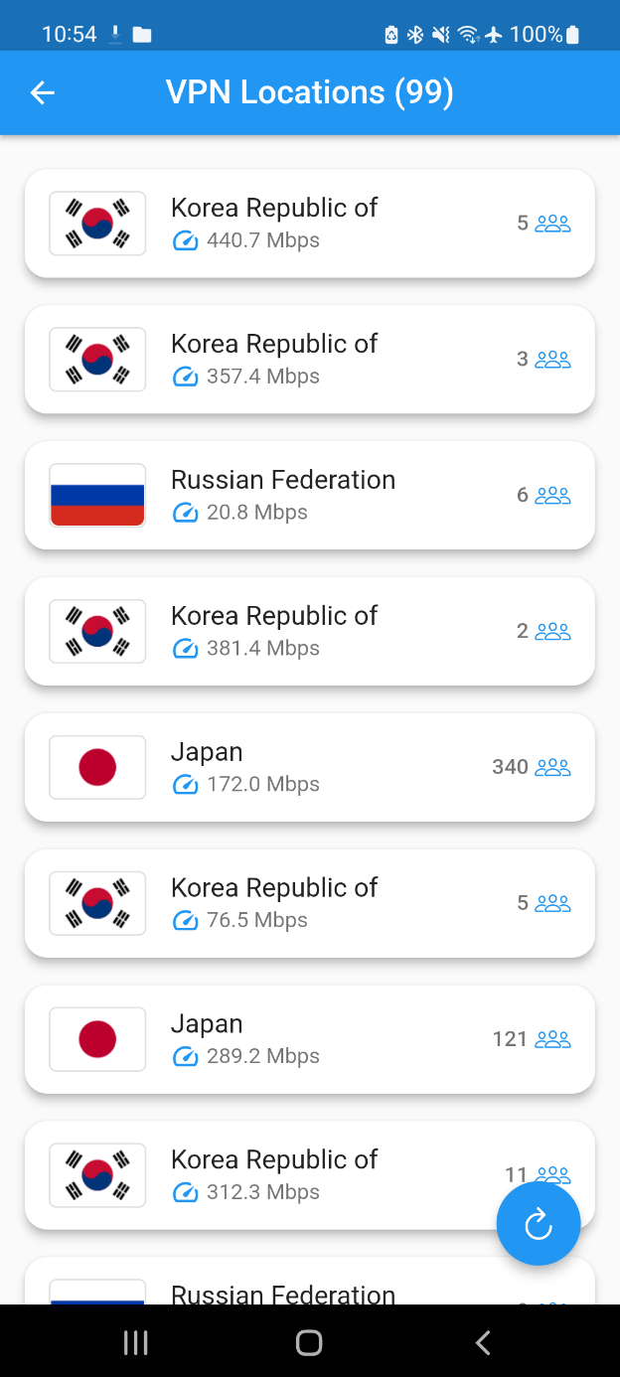 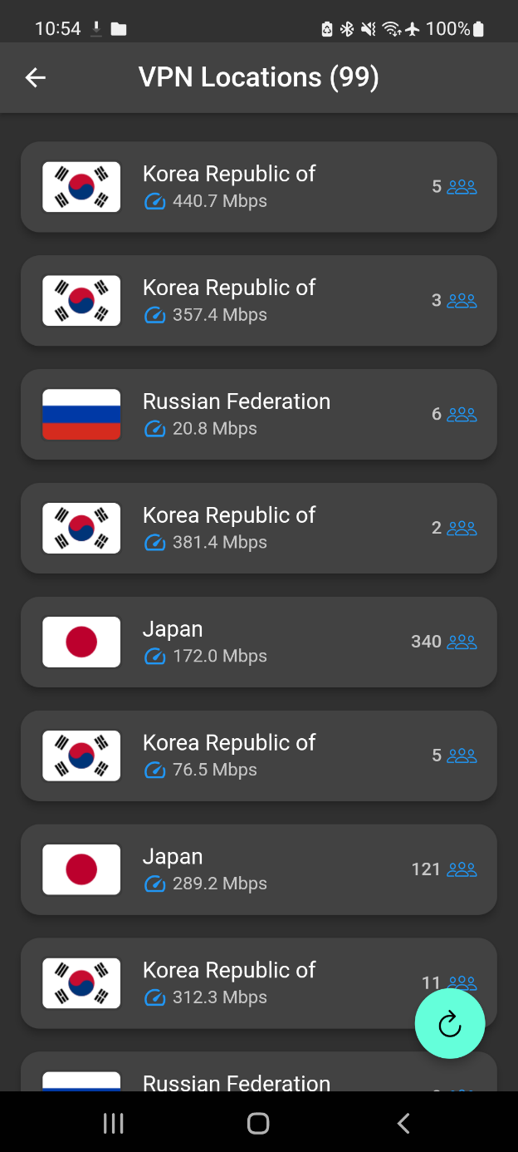

Fig no. 5,6

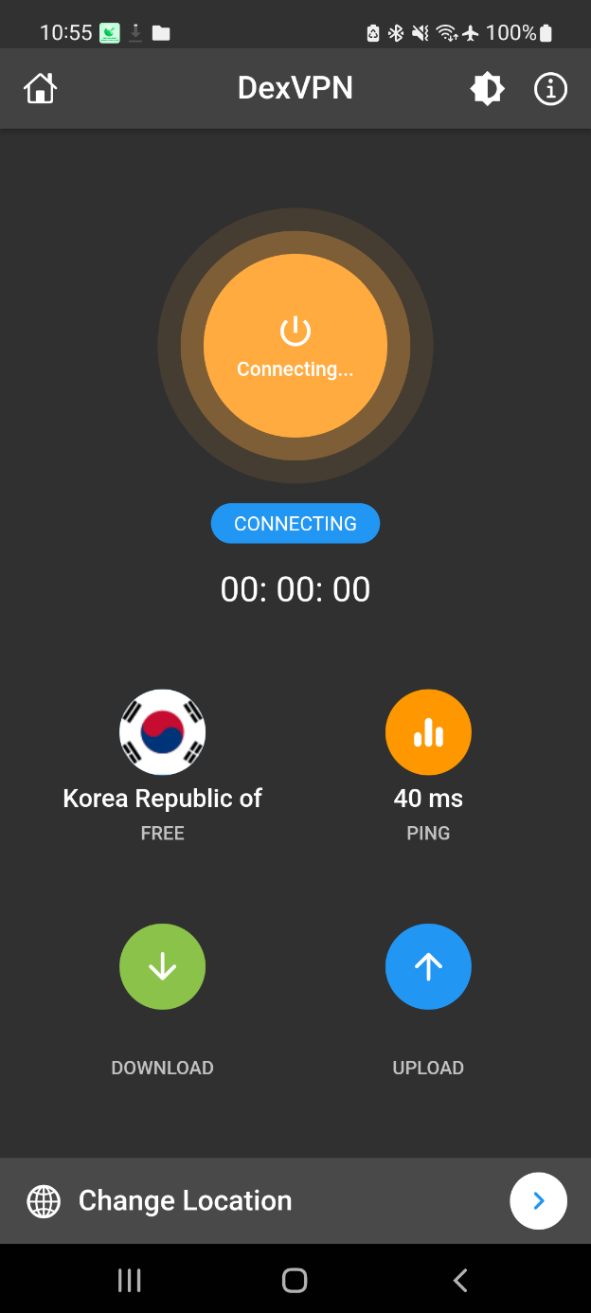 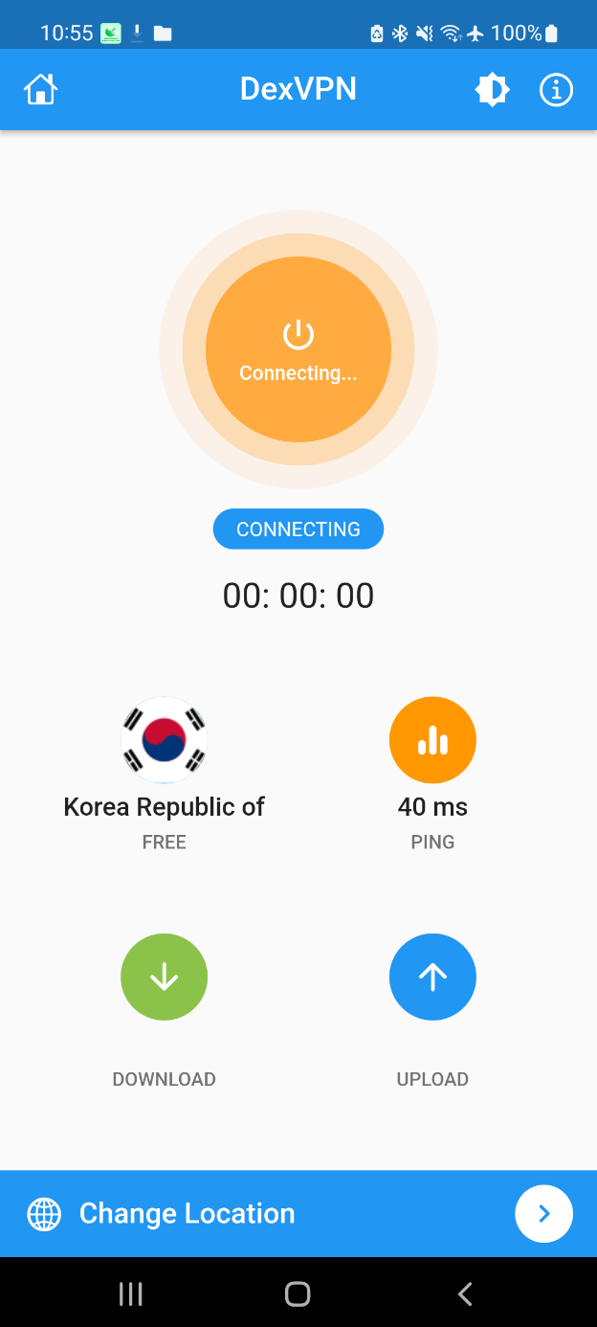

Fig no. 7,8

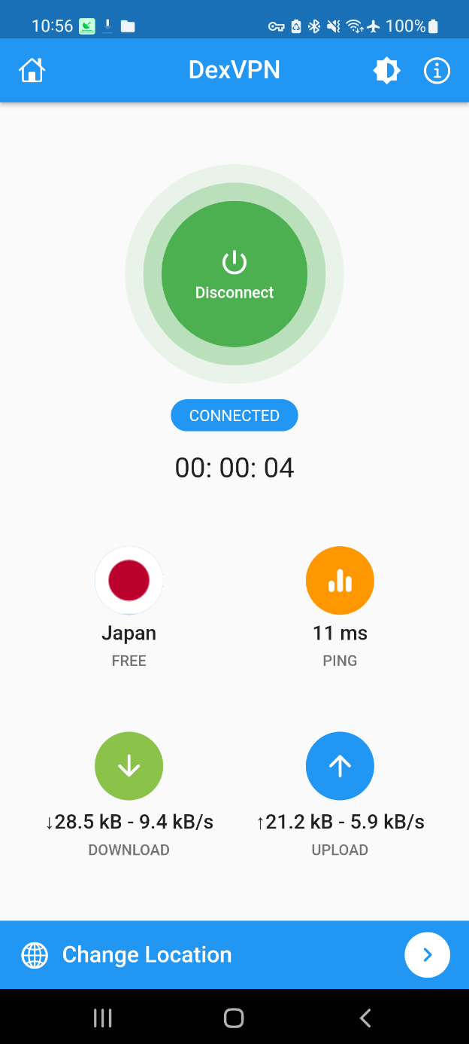 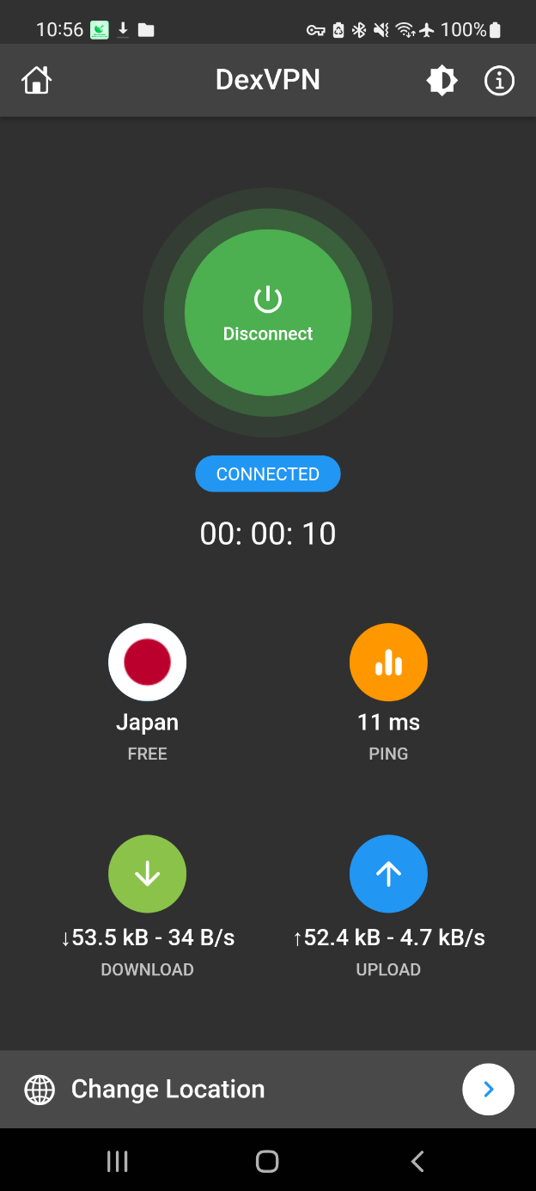

Fig no. 9,10

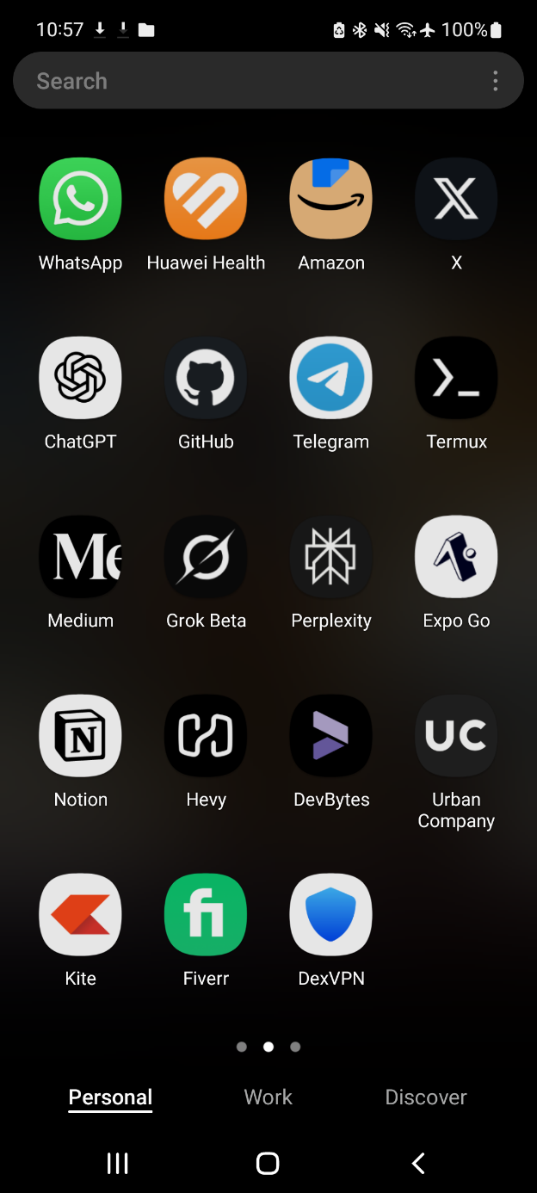

App Logo

Chapter 6 **CONCLUSION**

Our project aimed to address the increasing need for secure and reliable internet access, particularly for individuals seeking privacy and online freedom. We developed DexVPN, a platform that connects users with VPN servers, ensuring safe and encrypted browsing. Our platform provides a simple, user-friendly experience where users can easily connect to VPN servers based on their location preferences.

Through our research and development, we’ve identified the growing importance of privacy and security in today’s digital age. By offering a free, serverless solution, our platform ensures that users can access the internet securely without compromising on performance. The dynamic location feature ensures that users can select their preferred server locations, giving them full control over their online activities.

We believe that our project will not only benefit users seeking privacy but also contribute to promoting internet security and freedom across a wide range of users. Our platform’s simplicity and transparency make it accessible to both tech-savvy individuals and those new to using VPN services.

Overall, our project represents a significant step toward empowering individuals with better control over their online presence. We look forward to seeing DexVPN grow, ensuring a safer and more private online experience for all users.

Chapter 7 **BIBLIOGRAPHY&REFERENCES**

To develop the DEX VPN project, we used Flutter for the front-end, ensuring a cross-platform experience for both Android and iOS. For the backend, we leveraged third-party APIs to connect users with VPN servers, maintaining a serverless approach. We took inspiration from various resources and documentation to understand best practices for implementing secure and efficient VPN functionalities. Below are some of the key references that aided in the development of this project:

**References:**

1. [Stack Overflow](https://stackoverflow.com)  
   A valuable resource for solving coding challenges and finding community-driven solutions.
2. Flutter Official Documentation  
   Official documentation providing detailed insights and tutorials for building cross-platform apps using Flutter.
3. [VPNGate Documentation](https://www.vpngate.net)  
   A useful resource for understanding the VPN protocol, and available free VPN server lists to help integrate VPN features.
4. [OpenVPN Documentation](https://openvpn.net)  
   A comprehensive guide on using OpenVPN to establish secure connections and understand VPN networking.
5. [Dart Programming Language Documentation](https://dart.dev)  
   Official documentation for Dart, the programming language used with Flutter, providing necessary insights into its features and usage.